Cone-Based Composite Solids Formed by Addition

Definition
# Source: AI Source: Provided by: [Data Path: Persons Table -> ID Column: 1, Name_En Column: Motasem Essam] -> From: [ChatGPT] on [7/25/2026]
Cone-based composite solids are three-dimensional geometric objects formed by joining two or more cones or combining cones with other geometric solids to create a single composite structure.
The conical components may have identical or different base radii, heights, slant heights, and orientations. They can be connected through their circular bases, curved lateral surfaces, or other suitable contact regions.
These structures may contain one or more conical sections arranged vertically, horizontally, coaxially, symmetrically, or in other spatial configurations.
Examples include:
- Two cones joined at their circular bases.
- Two cones joined tip to tip.
- A cone attached to a cylinder.
- A cone placed on top of a cylindrical base.
- Multiple cones arranged around a central axis.
- A cone combined with a hemisphere or rectangular prism.

Simple Definition
# Source: AI Source: Provided by: [Data Path: Persons Table -> ID Column: 1, Name_En Column: Motasem Essam] -> From: [ChatGPT] on [7/25/2026]
A cone-based composite solid is a 3D shape formed by joining two or more cones or combining cones with other geometric solids.
Its total volume is calculated by adding the volumes of its components, while its external surface area includes only the exposed surfaces.

Geometric Representation
# Source: AI Source: Provided by: [Data Path: Persons Table -> ID Column: 1, Name_En Column: Motasem Essam] -> From: [ChatGPT] on [7/25/2026]
A cone-based composite solid may consist of several geometric elements:
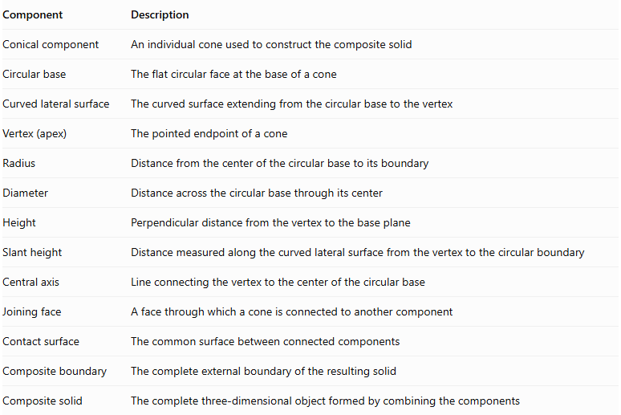
Component | Description
Conical component | An individual cone used to construct the composite solid
Circular base | The flat circular face at the base of a cone
Curved lateral surface | The curved surface extending from the circular base to the vertex
Vertex (apex) | The pointed endpoint of a cone
Radius | Distance from the center of the circular base to its boundary
Diameter | Distance across the circular base through its center
Height | Perpendicular distance from the vertex to the base plane
Slant height | Distance measured along the curved lateral surface from the vertex to the circular boundary
Central axis | Line connecting the vertex to the center of the circular base
Joining face | A face through which a cone is connected to another component
Contact surface | The common surface between connected components
Composite boundary | The complete external boundary of the resulting solid
Composite solid | The complete three-dimensional object formed by combining the components

Types of Cone-Based Composite Solids
# Source: AI Source: Provided by: [Data Path: Persons Table -> ID Column: 1, Name_En Column: Motasem Essam] -> From: [ChatGPT] on [7/25/2026]
These solids can be classified according to the arrangement and configuration of their conical components.

Coaxial Cone-Based Composite Solids
# Source: AI Source: Provided by: [Data Path: Persons Table -> ID Column: 1, Name_En Column: Motasem Essam] -> From: [ChatGPT] on [7/25/2026]
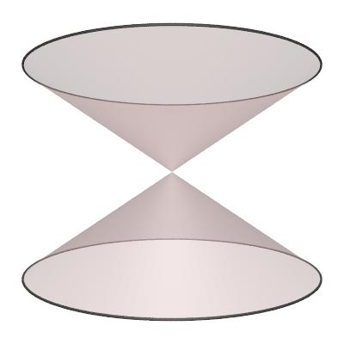
Created by joining two or more cones along a common central axis.
Examples:
- Two identical cones joined at their circular bases.
- Two cones with different heights joined at their bases.
- Two cones with different base radii arranged coaxially.
- Double-cone solid formed by joining two cones base to base.
- Multiple conical sections arranged along the same central axis.

Stacked Cone-Based Composite Solids
# Source: AI Source: Provided by: [Data Path: Persons Table -> ID Column: 1, Name_En Column: Motasem Essam] -> From: [ChatGPT] on [7/25/2026]
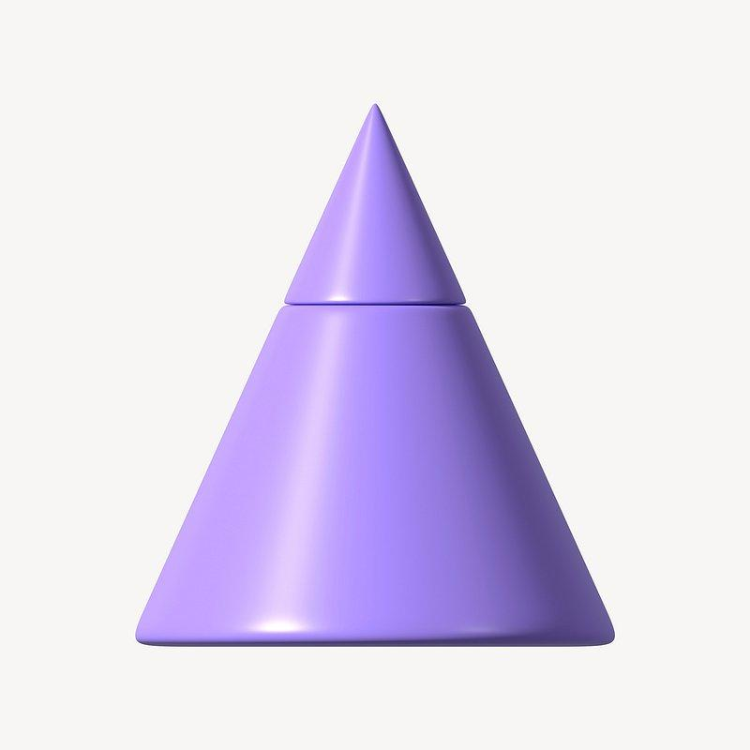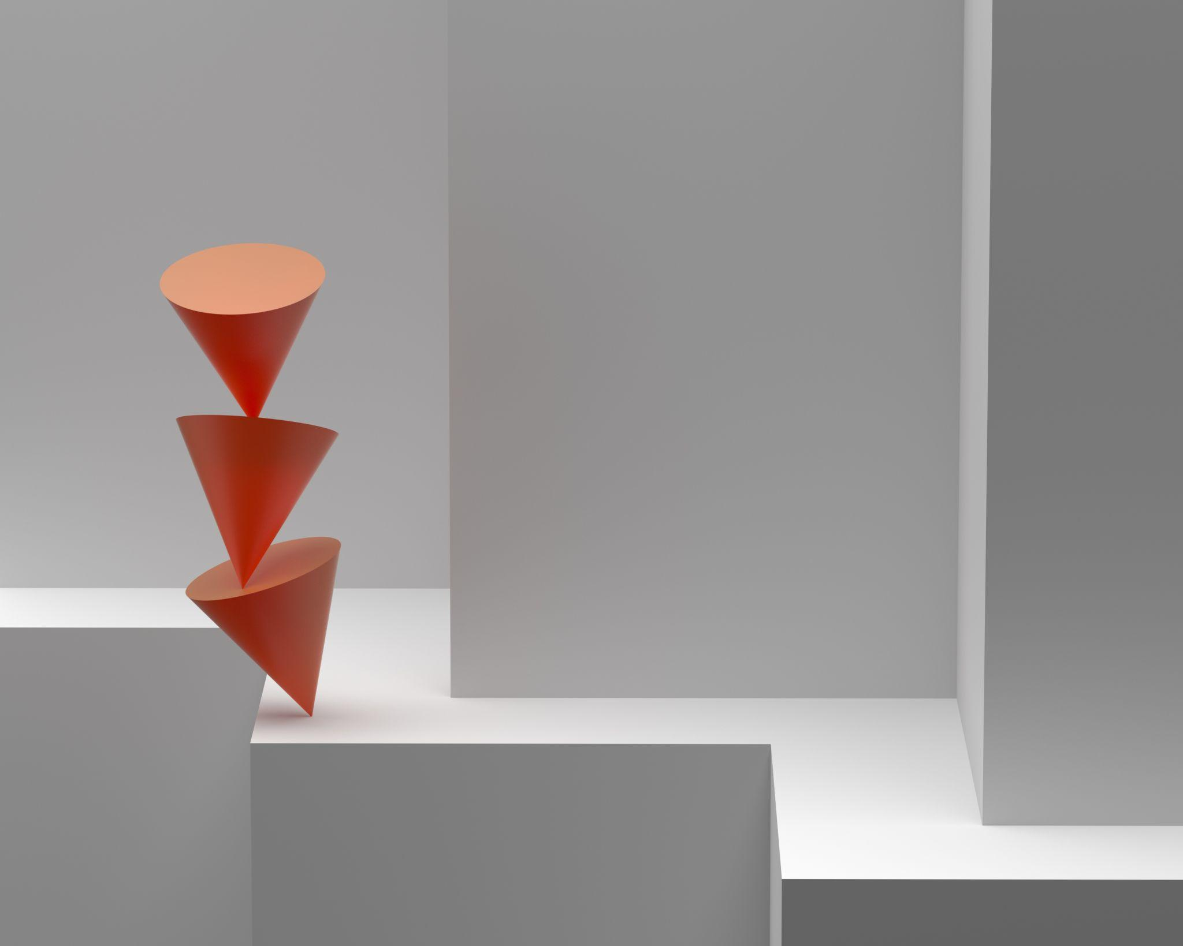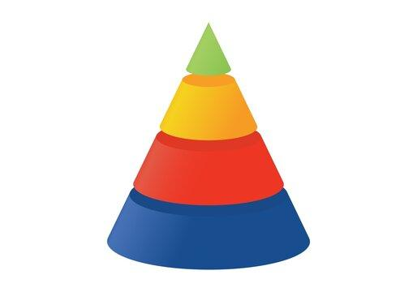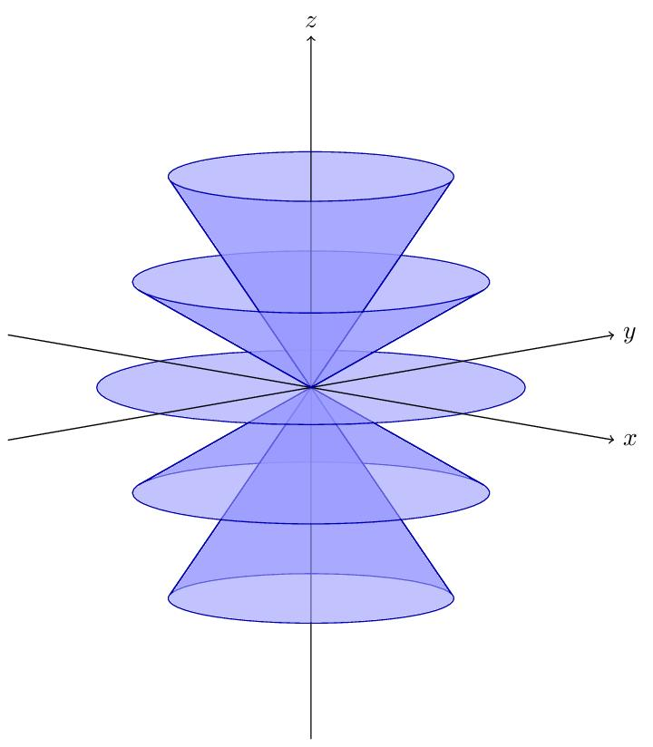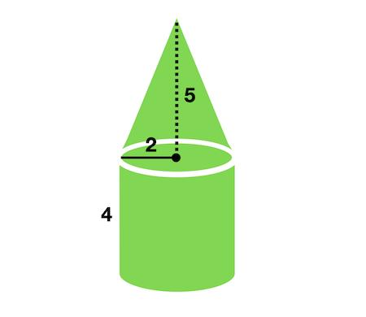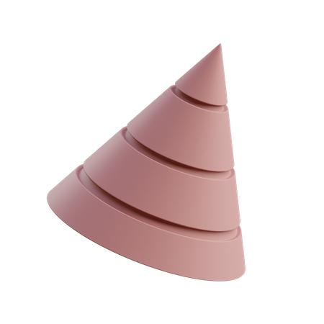
Created by placing multiple conical components one above another, with their bases or other suitable surfaces connected.
Examples:
- Two cones stacked vertically with matching circular bases.
- Cone placed on top of a cylindrical base.
- Multiple conical sections stacked in alternating orientations.
- Large cone with a smaller cone attached to its base.
- Composite conical column formed by repeated conical sections.

Apex-to-Apex Cone-Based Composite Solids
# Source: AI Source: Provided by: [Data Path: Persons Table -> ID Column: 1, Name_En Column: Motasem Essam] -> From: [ChatGPT] on [7/25/2026]
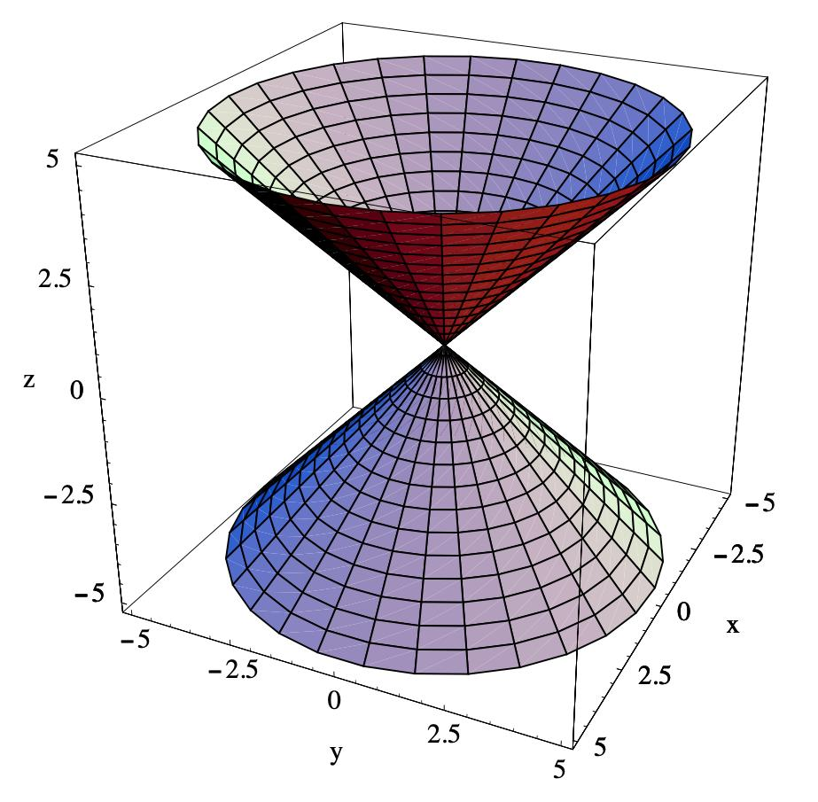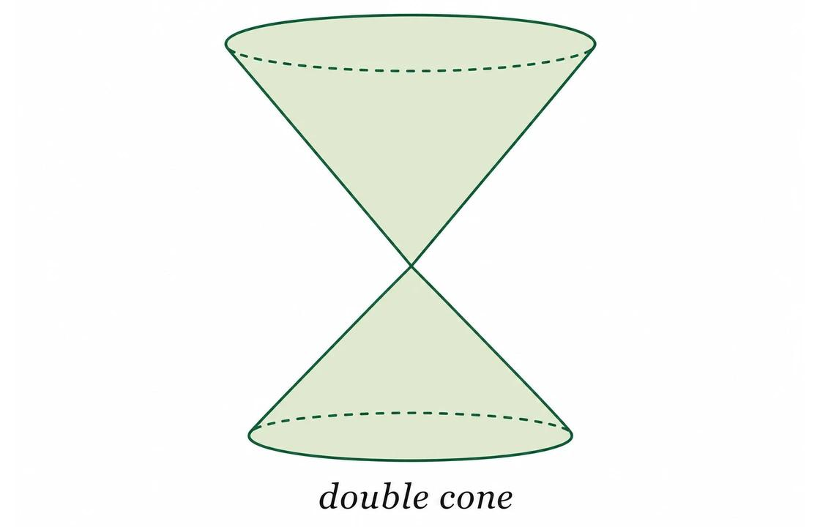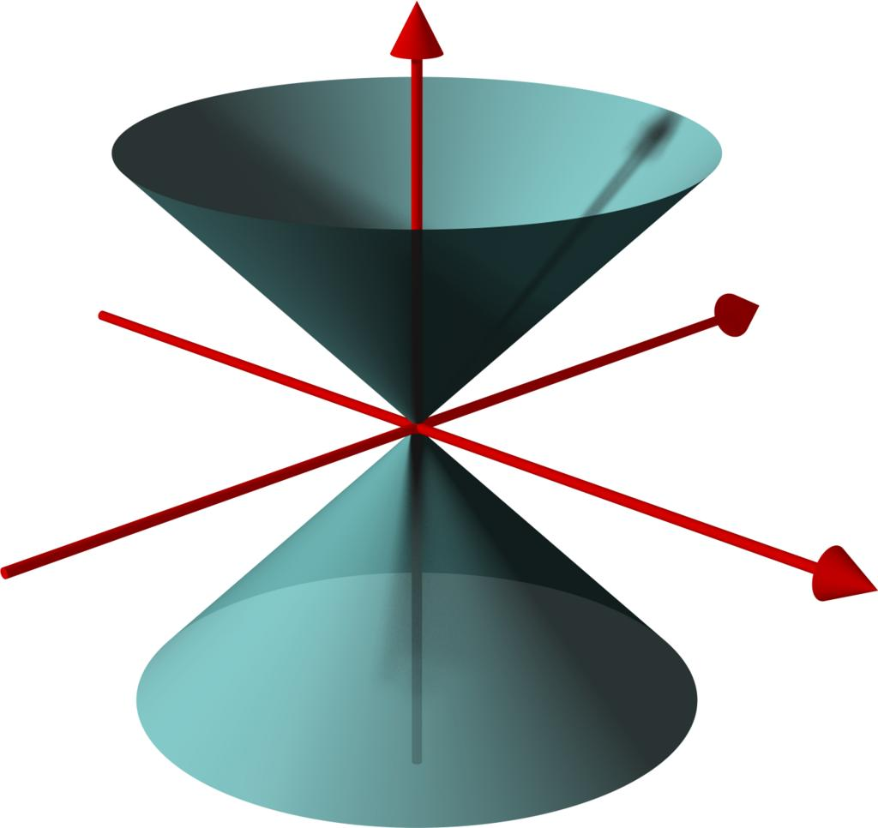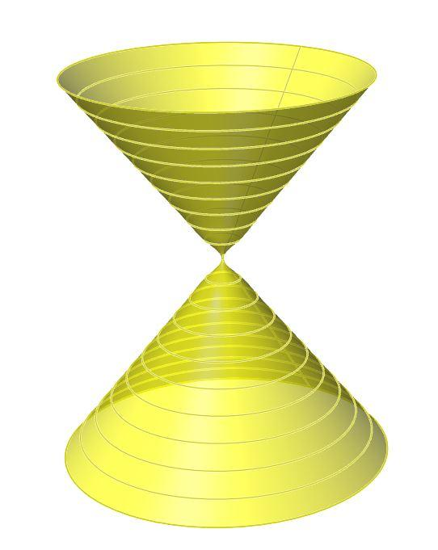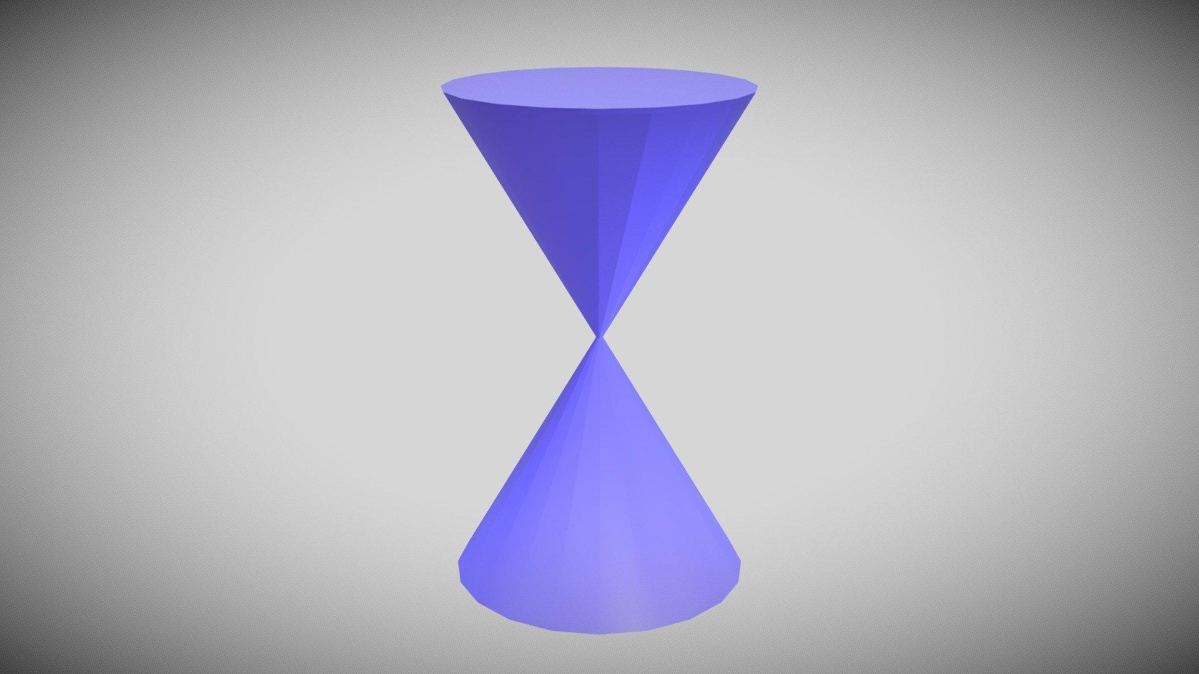
Created by positioning two or more cones so that their vertices meet at a common point.
Examples:
- Two identical cones joined tip to tip.
- Two cones with different base radii joined at their vertices.
- Two oppositely oriented cones with different heights.
- Multiple cones arranged around a common vertex.
- Symmetrical double-cone arrangement.

Base-to-Base Cone-Based Composite Solids
# Source: AI Source: Provided by: [Data Path: Persons Table -> ID Column: 1, Name_En Column: Motasem Essam] -> From: [ChatGPT] on [7/25/2026]
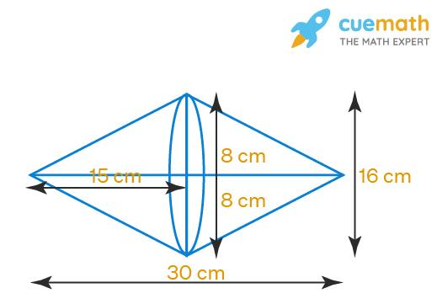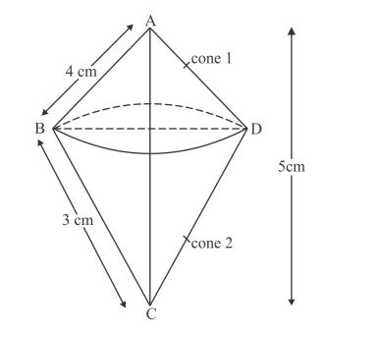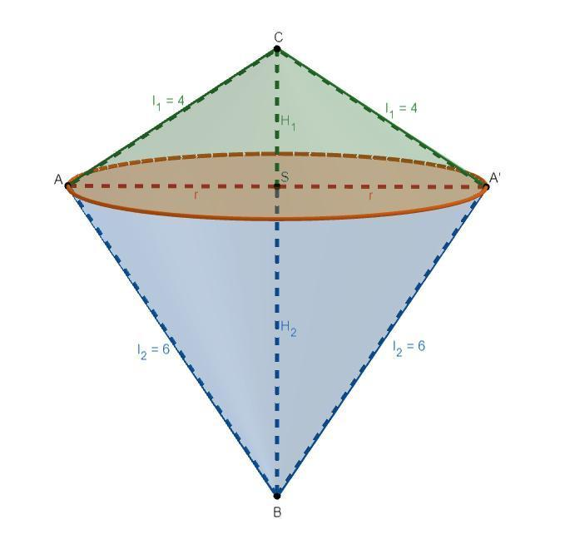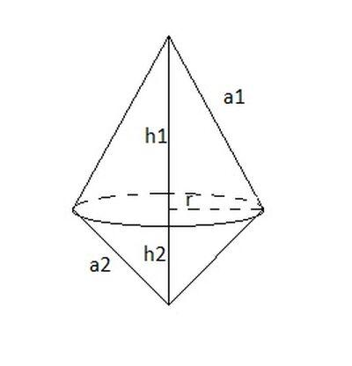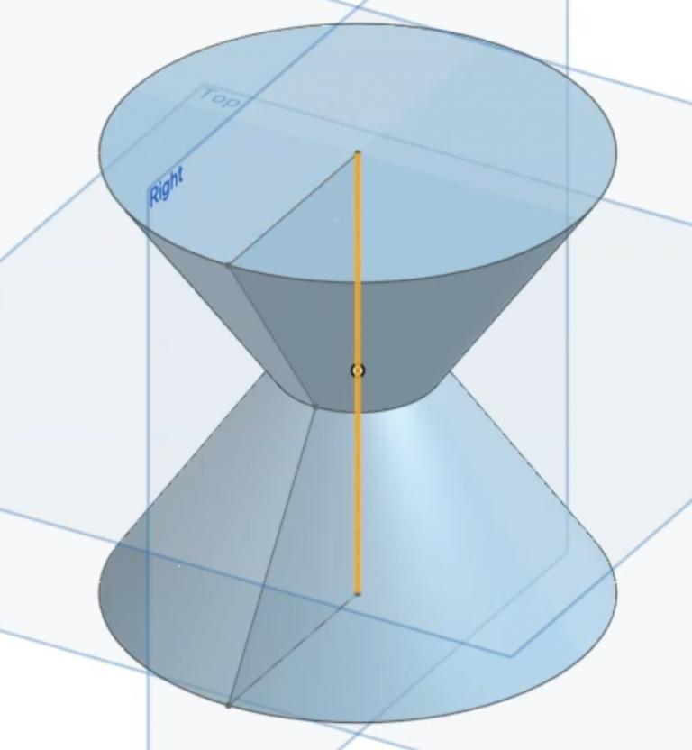
Created by joining two or more cones through their circular bases.
Examples:
- Two identical cones joined through matching circular bases.
- Two cones with different heights joined base to base.
- Two cones with different vertex angles joined through a common base.
- Double cone with equal upper and lower conical sections.
- Double cone with unequal upper and lower conical sections.

Side-by-Side Cone-Based Composite Solids
# Source: AI Source: Provided by: [Data Path: Persons Table -> ID Column: 1, Name_En Column: Motasem Essam] -> From: [ChatGPT] on [7/25/2026]
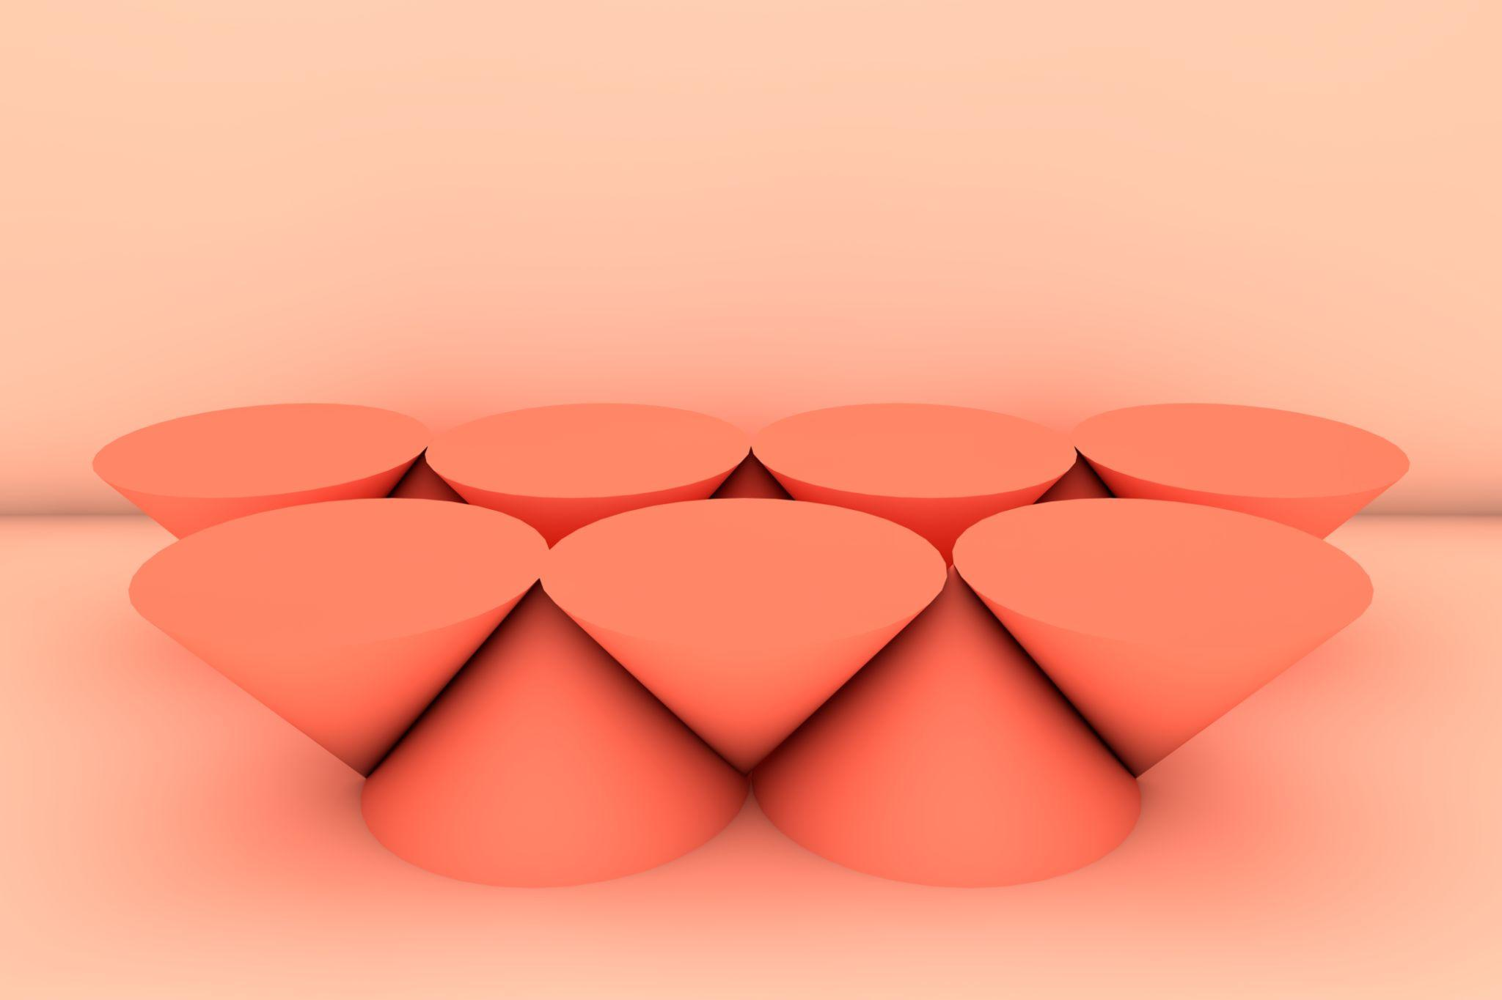
Created by arranging multiple conical components next to one another.
Examples:
- Two identical cones joined along suitable lateral regions.
- Multiple cones arranged in a straight row.
- Cones positioned side by side on a common base structure.
- Parallel conical components attached to a rectangular prism.
- Multiple cones arranged symmetrically along a common plane.

Radial Cone-Based Composite Solids
# Source: AI Source: Provided by: [Data Path: Persons Table -> ID Column: 1, Name_En Column: Motasem Essam] -> From: [ChatGPT] on [7/25/2026]
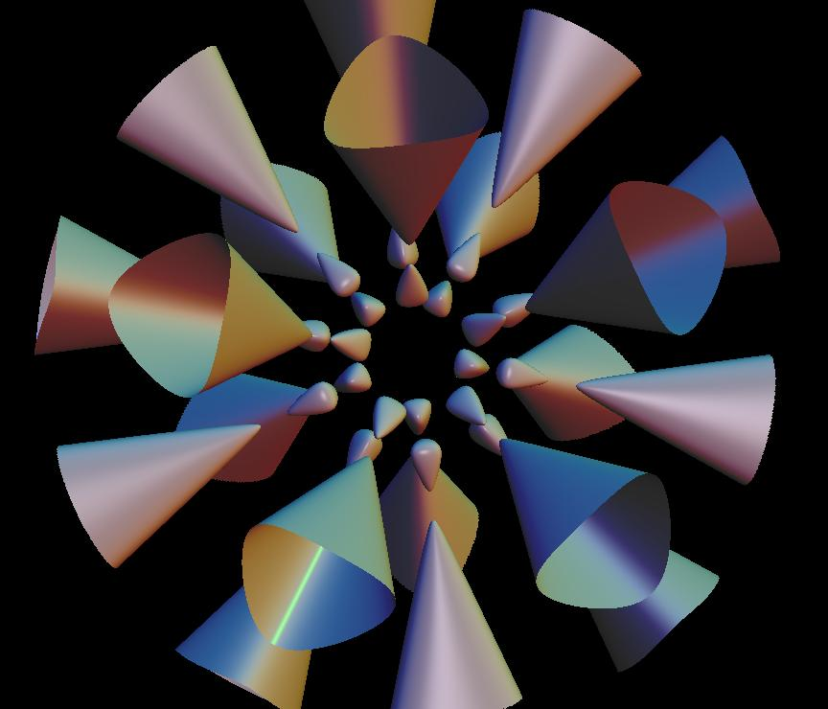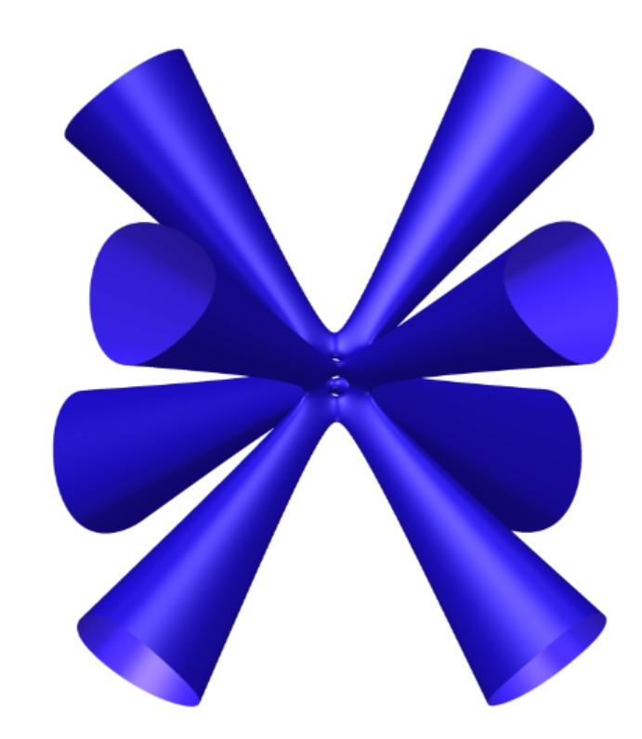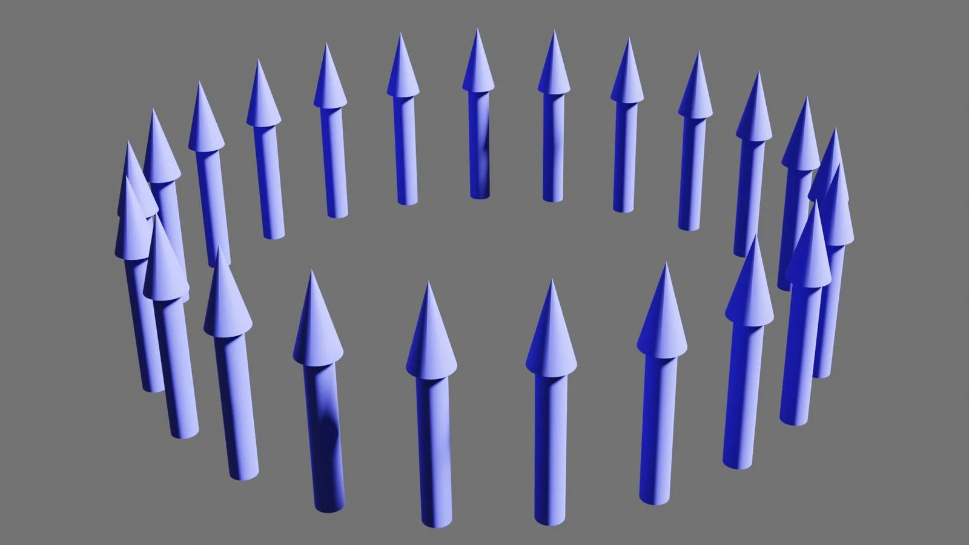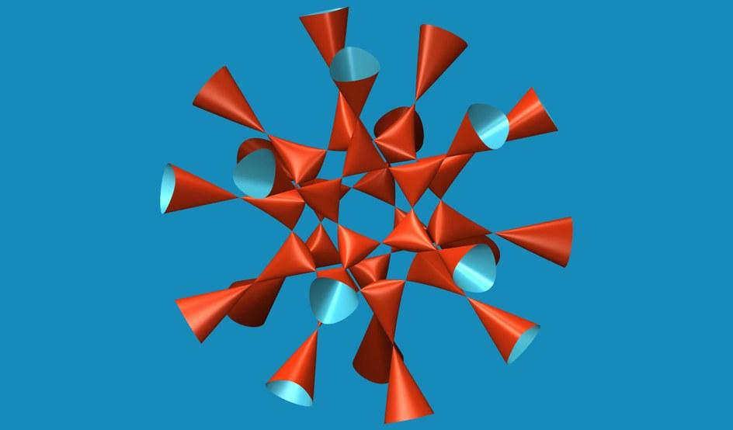
Created by arranging multiple cones around a central point or axis.
Examples:
- Multiple cones arranged around a central cylinder.
- Conical components distributed symmetrically around a central axis.
- Cones extending outward from a central geometric component.
- Circular arrangement of identical cones.
- Multiple cones arranged around a central prism.

Mixed-Shape Cone-Based Composite Solids
# Source: AI Source: Provided by: [Data Path: Persons Table -> ID Column: 1, Name_En Column: Motasem Essam] -> From: [ChatGPT] on [7/25/2026]
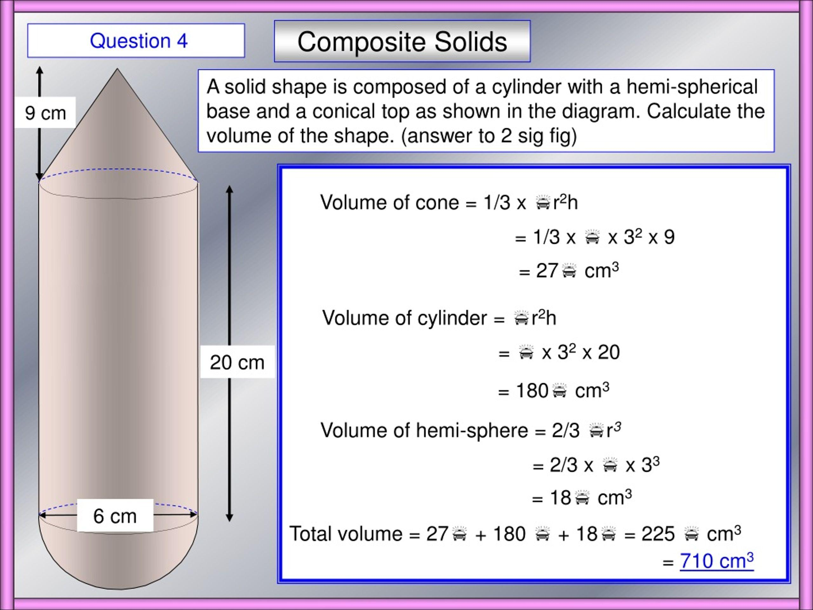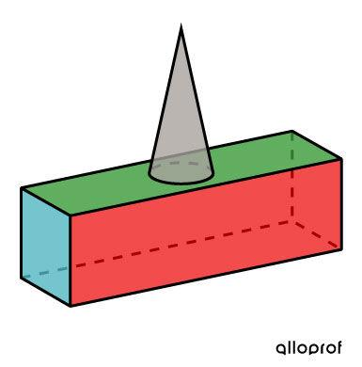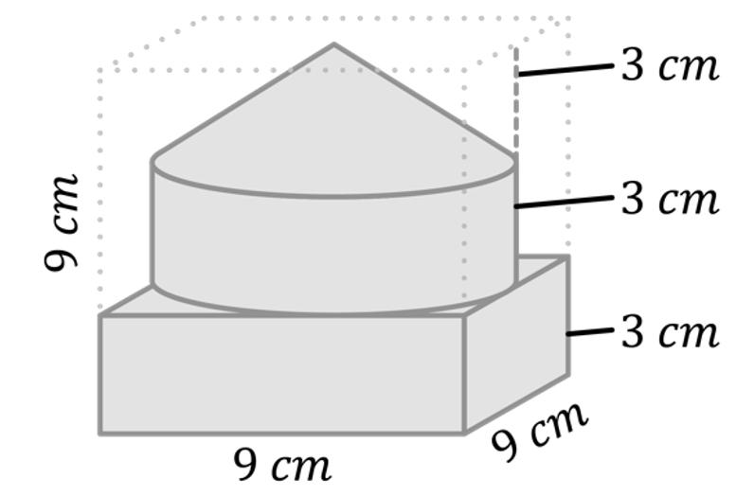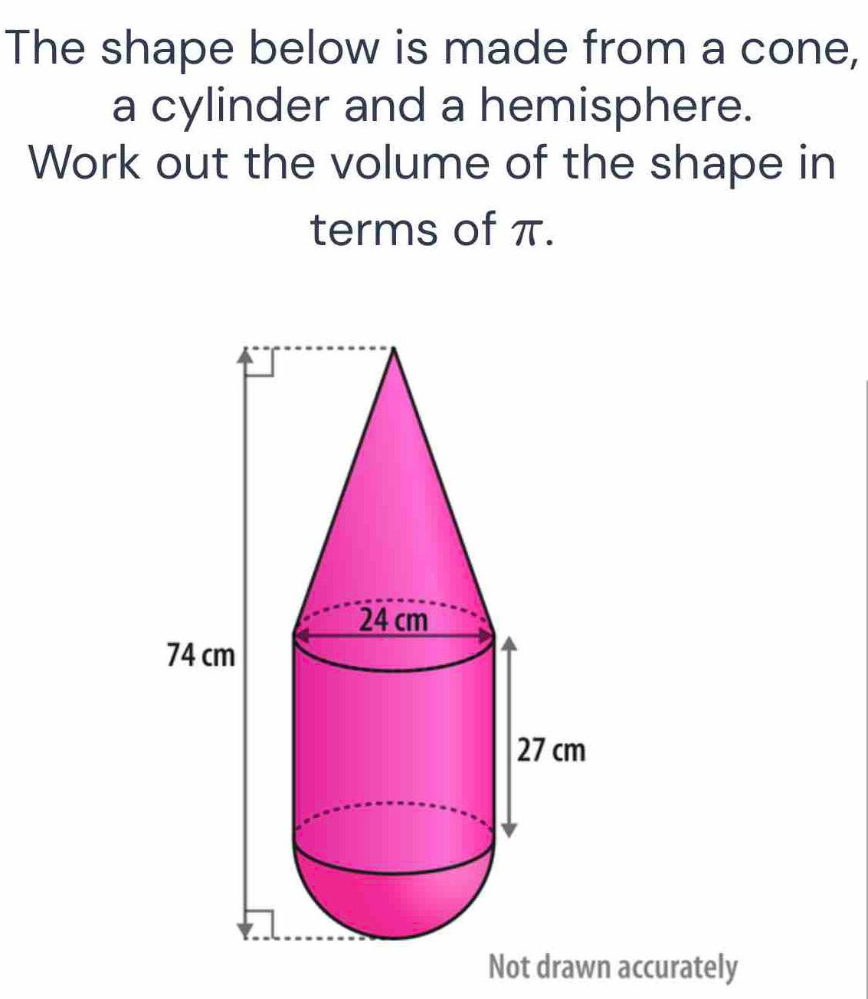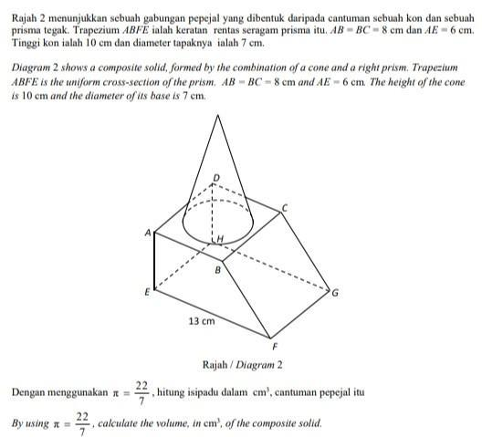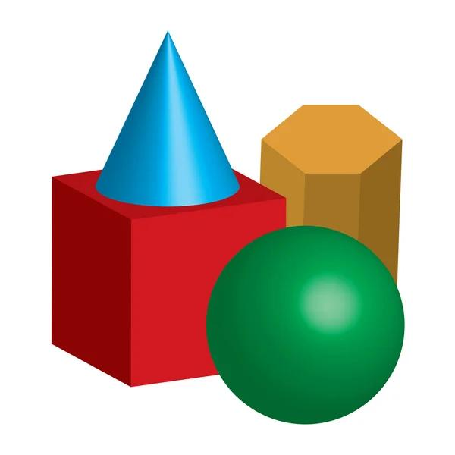
Created by combining one or more cones with other geometric solids.
Examples:
- Cone combined with a cylinder.
- Cone combined with a hemisphere.
- Cone combined with a sphere.
- Cone combined with a rectangular prism.
- Cone combined with a triangular prism.
- Multiple cones combined with cylinders and prisms.
- Composite solid formed by joining cones, hemispheres, and cylindrical sections.

Classification by Component Arrangement
# Source: AI Source: Provided by: [Data Path: Persons Table -> ID Column: 1, Name_En Column: Motasem Essam] -> From: [ChatGPT] on [7/25/2026]
Cone-based composite solids can also be classified according to how their conical components are positioned and connected.
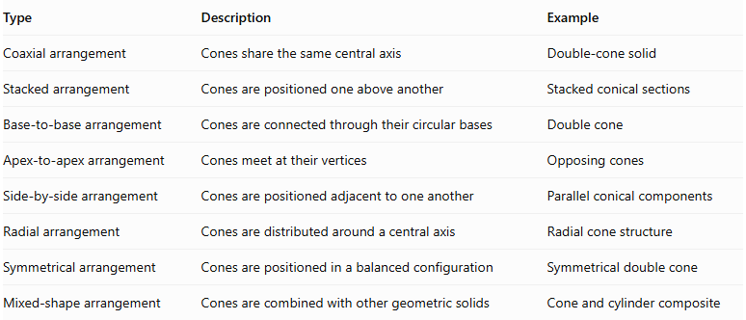
Type | Description | Example
Coaxial arrangement | Cones share the same central axis | Double-cone solid
Stacked arrangement | Cones are positioned one above another | Stacked conical sections
Base-to-base arrangement | Cones are connected through their circular bases | Double cone
Apex-to-apex arrangement | Cones meet at their vertices | Opposing cones
Side-by-side arrangement | Cones are positioned adjacent to one another | Parallel conical components
Radial arrangement | Cones are distributed around a central axis | Radial cone structure
Symmetrical arrangement | Cones are positioned in a balanced configuration | Symmetrical double cone
Mixed-shape arrangement | Cones are combined with other geometric solids | Cone and cylinder composite

Classification by Component Dimensions
# Source: AI Source: Provided by: [Data Path: Persons Table -> ID Column: 1, Name_En Column: Motasem Essam] -> From: [ChatGPT] on [7/25/2026]
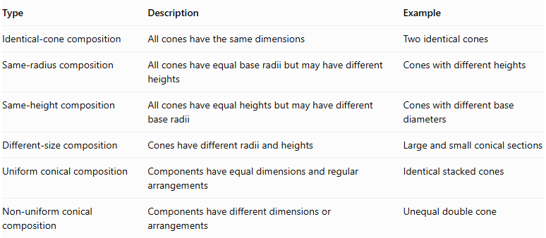
Type | Description | Example
Identical-cone composition | All cones have the same dimensions | Two identical cones
Same-radius composition | All cones have equal base radii but may have different heights | Cones with different heights
Same-height composition | All cones have equal heights but may have different base radii | Cones with different base diameters
Different-size composition | Cones have different radii and heights | Large and small conical sections
Uniform conical composition | Components have equal dimensions and regular arrangements | Identical stacked cones
Non-uniform conical composition | Components have different dimensions or arrangements | Unequal double cone

Mathematical Properties and Formulas

Total Volume
# Source: AI Source: Provided by: [Data Path: Persons Table -> ID Column: 1, Name_En Column: Motasem Essam] -> From: [ChatGPT] on [7/25/2026]
The volume of a cone-based composite solid is calculated by adding the volumes of its conical components.
For two cones:
$$\boxed{V_{total}=V_{1}+V_{2}}$$
For multiple non-overlapping cones:
$$\boxed{V_{total}=\sum_{i=1}^{n}{V_{i}}}$$
Where:
- $V_{total}$: Total volume of the composite solid.
- $V_{i}$: Volume of each conical component.
- $n$: Number of conical components.

Volume of a Cone
# Source: AI Source: Provided by: [Data Path: Persons Table -> ID Column: 1, Name_En Column: Motasem Essam] -> From: [ChatGPT] on [7/25/2026]
$$\boxed{V=\frac{1}{3}πr^{2}h}$$
Where:
- $r$: Radius of the circular base.
- $h$: Perpendicular height of the cone.
For $n$ identical cones:
$$\boxed{V_{total}=\frac{n}{3}πr^{2}h}$$

External Surface Area
# Source: AI Source: Provided by: [Data Path: Persons Table -> ID Column: 1, Name_En Column: Motasem Essam] -> From: [ChatGPT] on [7/25/2026]
The external surface area is the total area of all exposed surfaces of the composite conical solid.
For two cones joined through matching circular bases:
$$\boxed{{SA}_{total}={SA}_{1}+{SA}_{2}-2A_{contact}}$$
Where:
- ${SA}_{1}$: Total surface area of the first cone.
- ${SA}_{2}$: Total surface area of the second cone.
- $A_{contact}$: Area of their common circular joining face.

Total Surface Area of a Cone
# Source: AI Source: Provided by: [Data Path: Persons Table -> ID Column: 1, Name_En Column: Motasem Essam] -> From: [ChatGPT] on [7/25/2026]
$$\boxed{SA=πr^{2}+πrl}$$
Where:
- $πr^{2}$: Area of the circular base.
- $πrl$: Curved lateral surface area.
- $r$: Base radius.
- $l$: Slant height.
The slant height of a right circular cone is:
$$\boxed{l=\sqrt{r^{2}+h^{2}}}$$
Important: Internal contact surfaces must be excluded from external surface area calculations. For cones joined through their bases, the joined circular faces are not exposed. For cones meeting only at their vertices, the contact point has zero surface area.

Worked Examples

Example 1: Two Identical Cones Joined Base to Base
# Source: AI Source: Provided by: [Data Path: Persons Table -> ID Column: 1, Name_En Column: Motasem Essam] -> From: [ChatGPT] on [7/25/2026]
A composite solid is formed by joining two identical right circular cones through their circular bases.
Given:
- Number of cones: $n=2$
- Base radius: $r=3 cm$
- Height of each cone: $h=4 cm$
- Slant height: $l=5 cm$
Step 1: Calculate the volume of one cone
$$V_{1}=\frac{1}{3}πr^{2}h$$
$$V_{1}=\frac{1}{3}π(3)^{2}(4)$$
$$V_{1}=12π$$
Step 2: Calculate the total volume
$$V_{total}=2(12π)$$
$$\boxed{V_{total}=24π≈75.40{ cm}^{3}}$$
Step 3: Calculate the external surface area
Both circular bases are joined internally, so only the two curved lateral surfaces are exposed.
$${SA}_{total}=2πrl$$
$${SA}_{total}=2π(3)(5)$$
$$\boxed{{SA}_{total}=30π≈94.25{ cm}^{2}}$$

Example 2: Cone Attached to a Cylinder
# Source: AI Source: Provided by: [Data Path: Persons Table -> ID Column: 1, Name_En Column: Motasem Essam] -> From: [ChatGPT] on [7/25/2026]
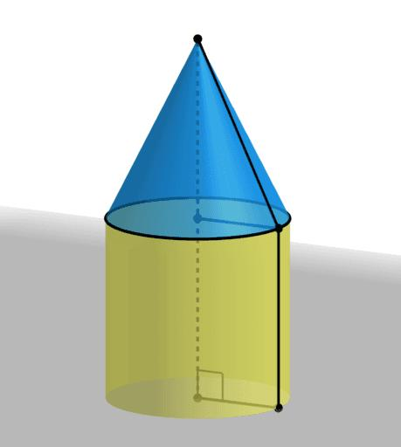
A cone is attached to the top of a cylinder. Both components have the same base radius.
Given:
Cylinder:
- Radius: $r=3 cm$
- Height: $h_{1}=6 cm$
Cone:
- Radius: $r=3 cm$
- Height: $h_{2}=4 cm$
- Slant height: $l=5 cm$
Step 1: Calculate the cylinder volume
$$V_{1}=πr^{2}h_{1}$$
$$V_{1}=π(3)^{2}(6)=54π$$
Step 2: Calculate the cone volume
$$V_{2}=\frac{1}{3}πr^{2}h_{2}$$
$$V_{2}=\frac{1}{3}π(3)^{2}(4)=12π$$
Step 3: Calculate the total volume
$$V_{total}=54π+12π$$
$$\boxed{V_{total}=66π≈207.35{ cm}^{3}}$$
Step 4: Calculate the external surface area
The exposed surfaces consist of:
- Cylinder curved lateral surface.
- One circular base at the bottom of the cylinder.
- Cone curved lateral surface.
$$SA=2π{rh}_{1}+πr^{2}+πrl$$
$$SA=2π(3)(6)+π(3)^{2}+π(3)(5)$$
$$SA=36π+9π+15π$$
$$\boxed{SA=60π≈188.50{ cm}^{2}}$$

Important Characteristics
# Source: AI Source: Provided by: [Data Path: Persons Table -> ID Column: 1, Name_En Column: Motasem Essam] -> From: [ChatGPT] on [7/25/2026]
- Formed by combining two or more cone-shaped components.
- Cones may have identical or different base radii and heights.
- Components can share a common central axis or have different orientations.
- Cones may be joined base to base, stacked, or arranged radially.
- Apex-to-apex arrangements can form double-cone structures.
- Cones can also be combined with cylinders, prisms, spheres, and hemispheres.
- Total volume is calculated by adding component volumes when their interiors do not overlap.
- External surface area includes only exposed circular bases and curved lateral surfaces.
- Internal joining surfaces must be excluded from external surface area calculations.

Comparison with Other Types of Composite Solids Formed by Addition
# Source: AI Source: Provided by: [Data Path: Persons Table -> ID Column: 1, Name_En Column: Motasem Essam] -> From: [ChatGPT] on [7/25/2026]
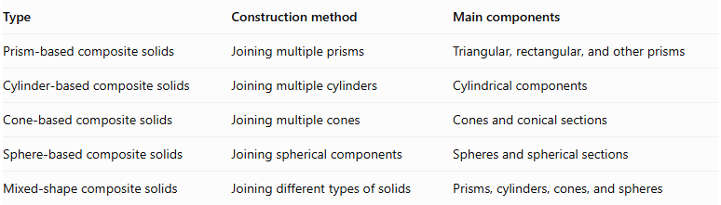
Type | Construction method | Main components
Prism-based composite solids | Joining multiple prisms | Triangular, rectangular, and other prisms
Cylinder-based composite solids | Joining multiple cylinders | Cylindrical components
Cone-based composite solids | Joining multiple cones | Cones and conical sections
Sphere-based composite solids | Joining spherical components | Spheres and spherical sections
Mixed-shape composite solids | Joining different types of solids | Prisms, cylinders, cones, and spheres

Applications
# Source: AI Source: Provided by: [Data Path: Persons Table -> ID Column: 1, Name_En Column: Motasem Essam] -> From: [ChatGPT] on [7/25/2026]
- Architecture: Designing conical roofs, towers, spires, and decorative structures.
- Mechanical engineering: Designing conical components, funnels, and tapered machine parts.
- Construction: Creating conical supports and structural elements.
- Manufacturing: Producing conical components and assemblies.
- Product design: Designing funnels, nozzles, containers, and decorative objects.
- Computer-aided design (CAD): Modeling complex conical structures using geometric combinations.

Key Points
# Source: AI Source: Provided by: [Data Path: Persons Table -> ID Column: 1, Name_En Column: Motasem Essam] -> From: [ChatGPT] on [7/25/2026]
- Cone-based composite solids are formed by joining two or more cones or combining cones with other solids.
- Cones may have identical or different dimensions.
- Common arrangements include coaxial, stacked, base-to-base, apex-to-apex, side-by-side, and radial configurations.
- Their total volume is calculated by adding component volumes, accounting for overlaps.
- Their external surface area includes only exposed surfaces.
- Internal joining surfaces must be excluded from external surface area calculations.
- They are widely used in architecture, engineering, manufacturing, and CAD.

Conclusion
# Source: AI Source: Provided by: [Data Path: Persons Table -> ID Column: 1, Name_En Column: Motasem Essam] -> From: [ChatGPT] on [7/25/2026]
Cone-based composite solids are three-dimensional geometric objects formed by combining multiple conical components or joining cones with other geometric solids. Their components may have different radii, heights, slant heights, and spatial arrangements, producing various conical structures. Understanding their geometric configurations and mathematical properties provides a foundation for calculating their total volume and external surface area and analyzing practical conical objects.

